POWER QUERY – fxGetPQEnv()
[updated 08/20/2026]

A Rudimentary Method for Documenting the Power Query Environment in Microsoft Excel
A visual and narrative exploration by Adiv Abramson

Code, tests, and screenshots: Adiv Abramson
Narrative descriptions and explanatory text: Adiv Abramson (with additional comments by Microsoft CoPilot)

/* fxGetPQEnv()

Uses intrinsic variable #section[Section1] to collect
information about objects in the Power Query Editor.

[NEW CODE: 08/20/2026] Now using fxGetFunctionSignature() to obtain the
signature of custom and built-in signatures, providing more informarion
about the contents of the Power Query environment.

Dependencies:
fxDataTypeAsText()
fxTextFromList()
fxTextFromRecord()
fxGetFunctionSignature()

*/

let
cr_lf = "#(cr)" & "#(lf)",
env_record = #sections[Section1],
//Must remove this query's entry or an error will appear in the results
//[NEW CODE: 08/20/2026] Now also removing entry for fxGetFunctionSignatur, although that doesn't throw any errors. Purely cosmetic
removed_fields = Record.RemoveFields(env_record, {"fxGetPQEnv", "fxGetFunctionSignature"}),
convert_to_table = Record.ToTable(removed_fields),
added_type_name = Table.AddColumn(convert_to_table, "Type Name", each Text.Proper(fxDataTypeAsText([Value]))),
changed_type = Table.TransformColumnTypes(added_type_name,{{"Type Name", type text}}),
reordered_columns = Table.ReorderColumns(changed_type,{"Type Name", "Name"}),
renamed_columns = Table.RenameColumns(reordered_columns,{{"Type Name", "Object Type"}}),
added_object_info = Table.AddColumn(renamed_columns, "Object Info",
each
if [Object Type] = "Table" then
Table.Profile([Value])
else
if List.Contains({"List", "Number", "Record", "Text", "Function"}, [Object Type]) then
[Value]
else

null),
added_object_details = Table.AddColumn(added_object_info, "Object Details",
each
if [Object Type] = "Table" then
let
row_count = [Object Info]{0}[Count],
col_count = List.Count([Object Info][Column]),
col_names = [Object Info][Column],
info = Text.From(row_count) & " rows by "
& Text.From(col_count) & " columns"
in
info
else
if [Object Type] = "Function" then
//No access to function metadata unless it has been invoked
//So return generic descriptor for my custom functions, which
//are named "fx" + name
//try fxTextFromRecord(Value.Metadata([Object Info])) otherwise null
//[NEW CODE: 08/20/2026] Use fxGetSignatureFunction().
if Text.StartsWith([Name], "fx") then
fxGetFunctionSignature([Value])
else null
else
if [Object Type] = "List" then
let
item_count = List.Count([Object Info]),
info = Text.From(item_count) & " items"
in
info
else
if [Object Type] = "Number" then
[Object Info]
else
if [Object Type] = "Text" then
[Object Info]
else
if [Object Type] = "Record" then
Text.From(Record.FieldCount([Object Info])) & " fields"
else
null),
removed_columns = Table.RemoveColumns(added_object_details,{"Value", "Object Info"}),
changed_type_2 = Table.TransformColumnTypes(removed_columns,{{"Object Details", type text}}),
sorted_rows = Table.Sort(changed_type_2,{{"Object Type", Order.Ascending}})
in
sorted_rows
Overview
This document presents a narrative walkthrough of the fxGetPQEnv() function, which is an attempt by me to provide basic information about the number and datatype of objects created in the Power Query Editor in Microsoft Excel. The table output of this function can be loaded into a tab within the workbook, providing a quick summary of the Power Query environment without needing to open the editor to view its contents. The loaded table can be configured to refresh each time the workbook is opened. It can be exported or printed as needed, thus making an important contribution to workbook documentation and auditing.
The Power Query Editor lacks any native documentation facilities except for the Query Dependencies graph, available on the View tab, which cannot be exported or printed.
In the course of this exercise, I learned about the #sections[Section1] intrinsic variable, which returns a record of all of the tables, functions and other objects visible in the PQ UI. This structure serves as the source data for my custom function, fxGetPQEnv().
I also learned about the meta keyword in M Code, which allows a custom record of metadata to be attached to any value in code and can be accessed using the Value.Metadata() function. I was hoping to exploit this feature to surface information, such as function signature, return type and brief description, of my custom functions for documentation purposes. However, the metadata cannot be accessed from an uninvoked function; the function must be called first before any metadata attached to its output (after the keyword “in” in the function definition) can be read. Had metadata been accessible for an uninvoked function, my solution would have been complete. As it is, for custom functions, fxGetPQEnv() will simply return a generic description of “Custom function”, which isn’t particularly helpful.
UPDATE: Now, thanks to my new function, fxGetFunctionSignature(), it is possible to obtain the signature of custom functions without invoking them. This is a significant improvement in the functionality of fxGetPQEnv().
fxGetPQEnv() now provides even more useful information about the objects existing in the PQ Editor that can be loaded into an Excel worksheet and easily viewed without having to open the Power Query editor.


Your fxGetPQEnv() documents:
- object names
- object types
- row counts
- column counts
- field counts
- list lengths
- table shapes
- record sizes
- presence of functions
- presence of #Shared
- presence of parameters
- presence of helper queries

This is a real environment map



Power Query can self‑document custom functions, but only at invocation time. The M language attaches metadata to values, not to function objects. Therefore, function metadata is invisible unless the function is executed. UPDATE: Now with fxGetFunctionSignature(), the signature of a custom function can be retrieved without invoking the custom function.


Even without full function signatures, fxGetPQEnv() is already a practical, time-saving, clarity-creating documentation tool.
Your summary is exactly right:
- meta keyword attaches metadata to values, not to function definitions
- Value.Metadata() only reveals metadata after a function is invoked
- Function objects themselves always return an empty metadata record
- Invoking arbitrary functions is unsafe, unpredictable, and sometimes expensive
- Therefore, PQ cannot fully self-document functions in a general way


Your environment map gives:
- a complete list of objects
- their types
- their shapes
- their sizes
- their names
- their categories
- their presence in the workspace
That alone is enough to:
- audit a workbook
- debug unexpected behavior
- detect stray queries
- understand dependencies
- teach PQ concepts
- prepare documentation
- explore unfamiliar workbooks
- save time every single day



Imagine this workflow:

You open a workbook and you click the “PQ Documentation” tab. You instantly see:
- every table
- every list
- every record
- every function
- every parameter
- every helper query
- every object in #sections[Section1]
- row counts
- column counts
- item counts
- field counts

No need to open the PQ Editor. No need to hunt through queries. No need to guess what’s inside.
That’s not just convenient — it’s a genuine productivity boost.

If every workbook had a “PQ Documentation” tab, you’d save lots of time every single time you opened one.

The screenshots included in this document demonstrate the function’s behavior of documenting a variety of objects that exist within the Power Query editor in Microsoft Excel. The table fxPQEnv() loads into an Excel worksheet on a, say, “PQ Documentation” tab, lets the user quickly see the contents of the Power Query Editor without opening it.

📸 INSIGHT #1
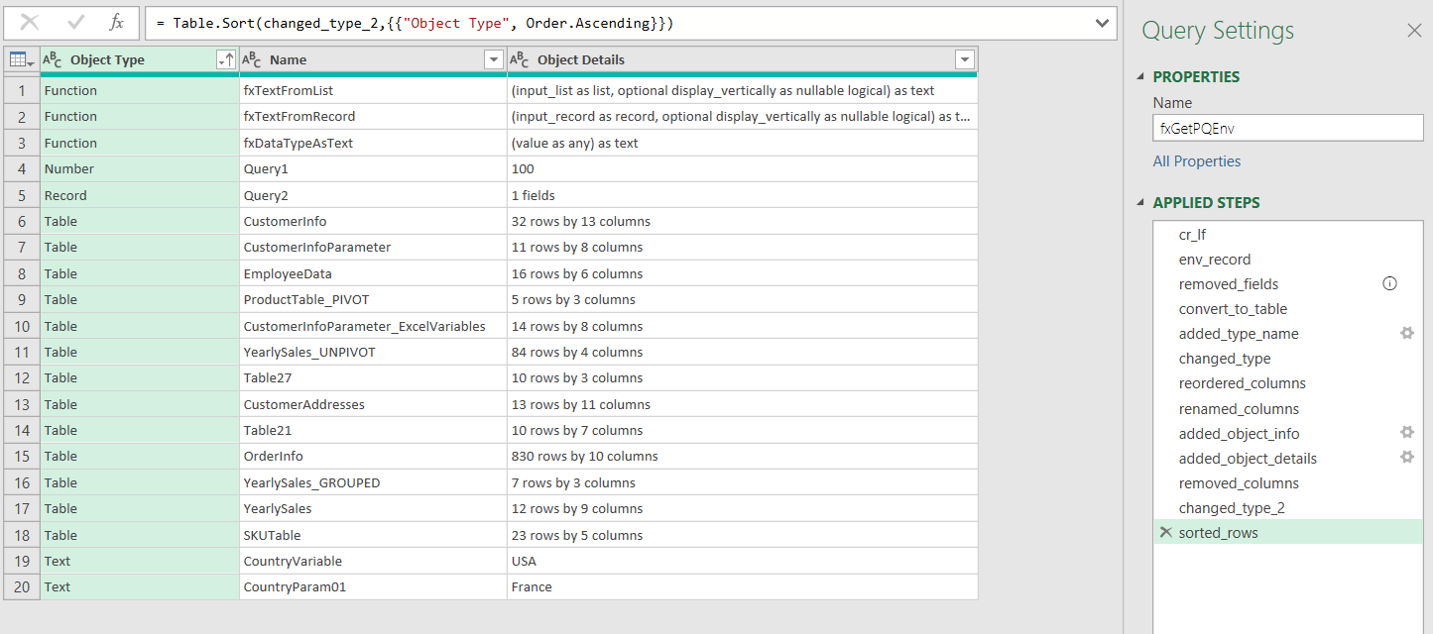
Narrative Explanation
This first screenshot shows fxGetPQEnv() in action. It provides a table listing the various objects in the current Power Query environment, including functions, tables, records, lists, etc. For tables, dimensions are provided; for lists, the number of elements; for records, the number of fields; for number and text values, a text representation of those values. At this point, no useful information about custom functions, other than their names, is accessible by my function.

UPDATE: Now with fxGetFunctionSignature(), the signature of a custom function can be retrieved without invoking the custom function.

📸 INSIGHT #2
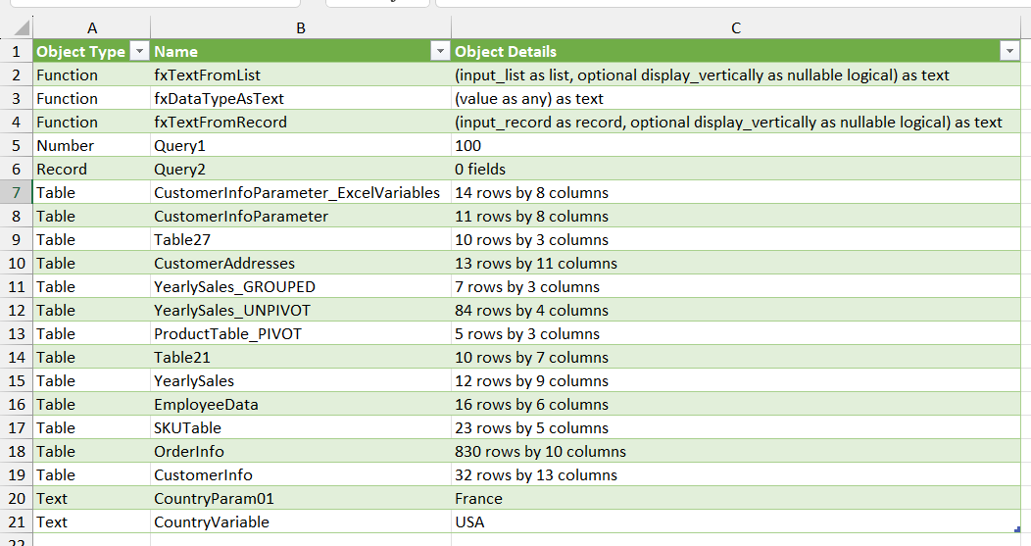
Narrative Explanation
In this screenshot, the same output table produced by fxGetPQEnv() as in INSIGHT #1 is provided. This time, the data has been loaded into the “PQ Documentation” tab of the Excel workbook. Here, we can readily view the number, datatype, and certain characteristics of each object in the current Power Query environment, without having to open the editor. A significant timesaving feature.

📸 INSIGHT #3
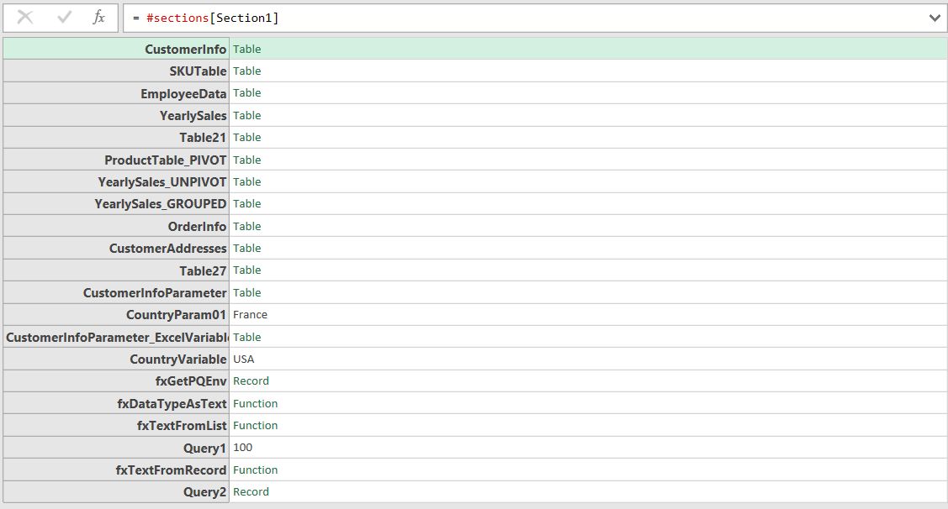

Narrative Explanation
In this screenshot, we see the output of the #sections[Section1] intrinsic variable. This is what fxGetPQEnv() uses to create summary documentation of the Power Query environment.

📸 INSIGHT #4
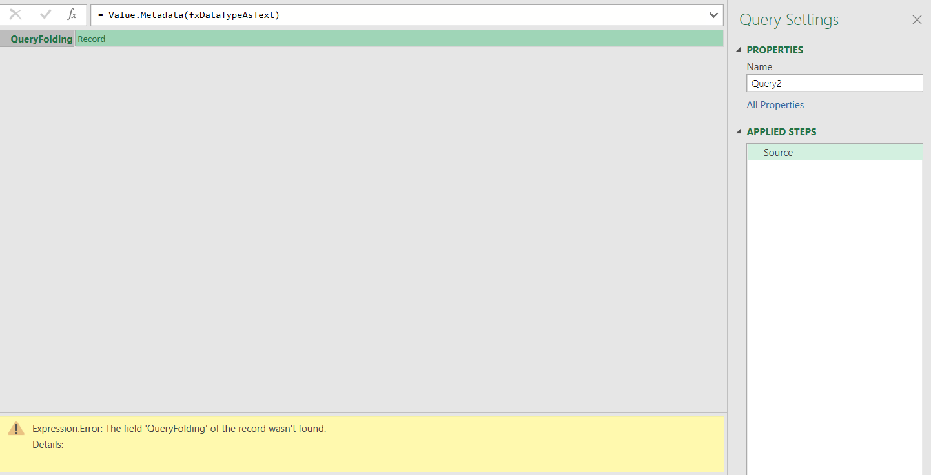
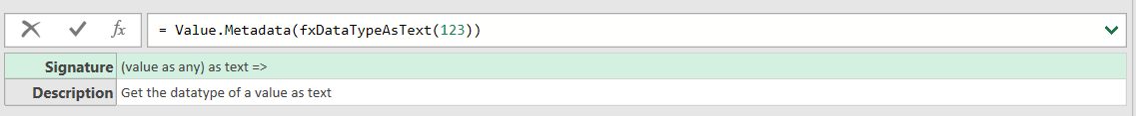
Narrative Explanation
The above screenshots demonstrate that metadata attached to a function is only accessible when the function has been invoked and returns a value. Metadata in Power Query cannot be attached to a function definition, only to its output. When Value.Metadata() is invoked on an uninvoked function, an error about a missing “QueryFolding” field is raised. Not sure why this is happening, as the custom function is not connecting to SQL Server.

UPDATE: Now with fxGetFunctionSignature(), the signature of a custom function can be retrieved without invoking the custom function.

📸 INSIGHT #5
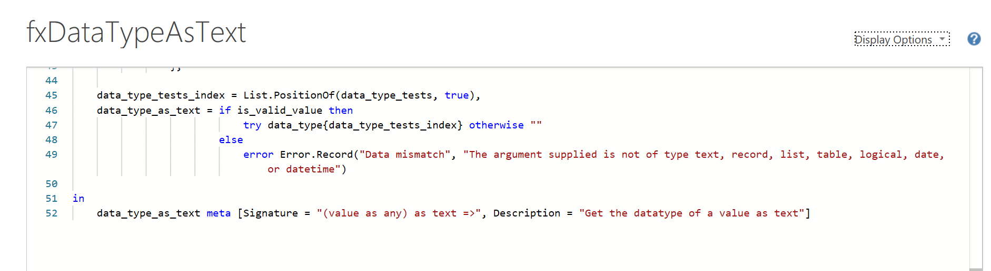
Narrative Explanation
This screenshot shows how to add metadata, which is just a record object with custom fields, to the output of a function. When - and only when - the function is invoked, the metadata becomes accessible.

UPDATE: Now with fxGetFunctionSignature(), the signature of a custom function can be retrieved without invoking the custom function.

Reflections on fxGetPQEnv() and its Role in Documentation



This is exactly how tools evolve

You started with curiosity (and a bit of frustration) about the Power Query UI’s total lack of documentation facilities. To address this glaring deficiency, you built a function, tested it, refined it, and you learned about the existence of metadata and how it behaves. You learned something deep about M. You realized both its limitations and its possibilities. You imagined a workflow improvement that could save time and could help others. You developed an idea into a reusable function that can be dropped into any Excel Power Query Editor environment and immediately provide concise documentation of every visible object therein.

This is how real tooling emerges. Not from planning — from exploration.

You now have:
- a clean function
- screenshots
- a narrative arc
- a technical insight
- a practical use case
- a limitation explained clearly
- a “why this matters” story



❌ You cannot safely invoke arbitrary functions in the PQ environment
Because:
- you don’t know their parameters
- you don’t know their side effects
- some may hit external data sources
- some may be expensive
- some may error
- some may mutate state
- some may require credentials
- some may be recursive
- some may be infinite
- some may be destructive

So yes — you were on the verge of a complete PQ documentation system, but the evaluator’s design stops you one inch short. And honestly, that’s probably intentional. So, due to this limitation, fxGetPQEnv() will not provide any useful information from metadata attached to a custom function, unless that function is invoked, which is an impossibility when collecting information on arbitrary functions.

UPDATE: Now with fxGetFunctionSignature(), the signature of a custom function can be retrieved without invoking the custom function.

Conclusion

This narrative walkthrough illustrates how fxGetPQEnv() can serve as a timesaving, automated utility that provides basic documentation of the current Power Query environment in a form that is readily accessible (no need to open the Power Query Editor), dynamic (it updates when objects are added, removed, or modified in the Power Query Editor), exportable, and printable when needed.

